BRABUS Automotive GmbH and Great Wall Motor Co. Ltd sign a master agreement on their strategic cooperation at the Geneva Motor Show 2019

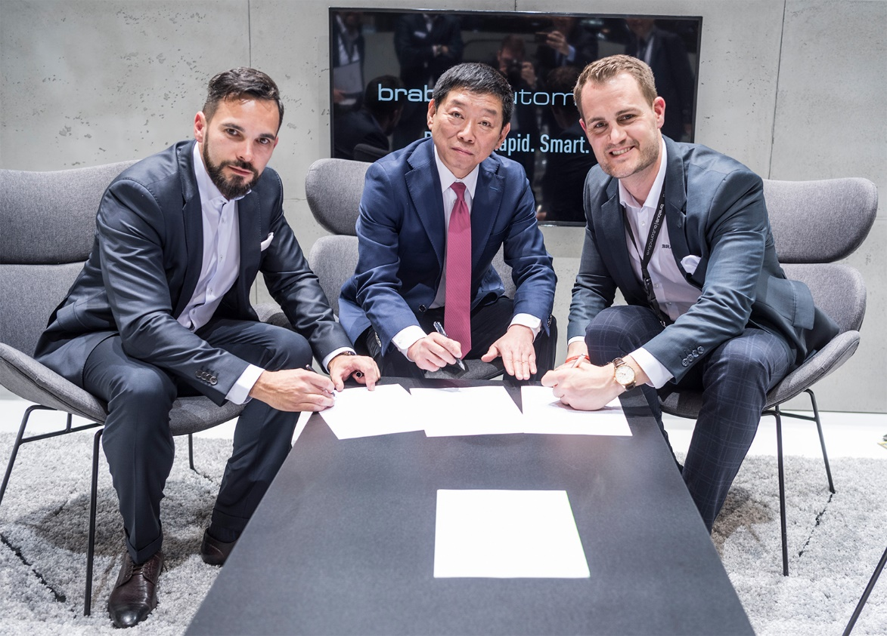
Christian Draser, CEO of Brabus Automotive GmbH, Wei Jianjun, Chairman of Great Wall Motor Co. Ltd. and founder of the WEY brand, and Constantin Buschmann, CEO of BRABUS GROUP, sign the cooperation agreement at the Geneva Motor Show 2019 (from left).

On March 6, 2019, BRABUS Automotive GmbH and Great Wall Motor Co. Ltd. signed a master agreement at the Geneva Motor Show on the strategic cooperation of the two companies. Constantin Buschmann, CEO of BRABUS GROUP, Christian Draser, CEO of BRABUS Automotive GmbH, and Wei Jianjun, Chairman of Great Wall Motor Co. Ltd. and founder of the WEY brand, signed the agreement.
As a specialized general contractor, brabus|automotive offers turnkey project realizations of small and special production runs for renowned automakers from around the world, whose implementation is only feasible with great difficulty in large OEM structures. Great Wall Motor is the largest Chinese manufacturer of SUVs and pickups, with WEY being the brand for the company's luxury SUVs.
The goal of this cooperation is the development and production of limited special series, special annual editions as well as enhanced versions of the top-of-the-range models of the Great Wall Motor and WEY brands. In addition, both parties will advance joint research and development projects and cooperate in the area of alternative powertrains, for example. The global cooperation with Great Wall Motor also comprises brabus|automotive support for exterior and interior design, for the homologation of the vehicles for the European market, as well as for the assessment of the realization of joint ventures.
This cooperation underpins the significance of the general contractor idea of brabus|automotive for the international auto industry. It also advances the global vision of Great Wall Motor of developing new markets. Finally, this agreement demonstrates the determination of both companies to take leading roles in their particular fields.

BRABUS Automotive GmbH, a BRABUS GROUP company, specializes in highly flexible, superior contract manufacturing of motor vehicles in small and special production runs with studio-type production processes that meet the highest OEM standards on quality and customization. As a general contractor, brabus|automotive is considered one of the most sought-after development partners of the international auto industry.

The strategic cooperation of Great Wall Motor and brabus|automotive will help to establish the Chinese manufacturer on the global market and make the mission of the WEY brand, "luxury you can touch," a reality. At the upcoming IAA 2019 auto show in Frankfurt am Main, Great Wall Motor will present a new model, whose exterior and interior were extensively revised by brabus|automotive for the European market and to serve as the basis for the series production.

To live up to the constantly growing demand for automotive refinement and customization on the Chinese market, Fengying Wang, Deputy Chairwoman of Great Wall Motor, presented a proposal on the "standardization and promotion of modifications to cars" at the People's National Assembly 2019 in Beijing to ensure that customers in China will have even more fun with their cars in future. The cooperation of Great Wall Motors and brabus|automotive illustrates the strategy of WEY of satisfying the demand for customization and sportiness, and thus also of making WEY the flagship of Chinese automotive culture.

BRABUS Automotive GmbH: a brief portrait:
brabus|automotive is the specialist for the turnkey project realization of small and special production runs, which in OEM structures are only feasible with great difficulty. This comprises development processes and superior studio-type manufacturing processes that meet the highest standards on quality and customization requirements along the entire product creation process.
The German company headquartered in Bottrop bundles the development and production services for automakers under one roof. In one place, from a single source, from individual components to complete cars, from one-offs to small production runs.
As a general contractor, brabus|automotive is one of the most professional full-service providers of the industry today. The company management lies in the hands of the two CEOs, Christian Draser (Chairman) and Constantin Buschmann.

Great Wall Motor Co. Ltd.: a brief portrait:
Great Wall Motor Co. Ltd., headquartered in Baoding in Hebei province, is the largest Chinese manufacturer of SUVs and pickups, and employs a workforce of about 80,000. Apart from a joint venture with BMW Group, the company has maintained a cooperation with brabus|automotive since March 2019.
Great Wall Motor is represented on the market with three brands: Haval is the number-one SUV brand in China. Pickups are marketed under the Great Wall brand name. WEY produces luxury SUVs. Since 2018, Great Wall Motor has been offering electric cars under the "Ora" label.

brabus|automotive 2019.
Copyright free!
Please send us a copy of the printed article or a link
to your online coverage. Thank you!
Please note: More information about brabus|automotive for you and your readers is available on the internet at www.brabus-automotive.de.

